# June 23, 2016

FRONT RANGE FIRE RESCUE

# [www.FRFR.co](http://www.FRFR.co/)

Mr. Jeremiah Clymer,

Congratulations! You have successfully completed all stages of the hiring process and we are pleased to offer you a conditional position as a Probationary Reserve Firefighter with Front Range Fire Rescue.

Your appointment as a Reserve Firefighter is based on the condition that all required certifications are verified along with the successful completion of a background check, drug test and medical examination.

Please present a minimum of a valid State of Colorado Firefighter I and Hazardous Materials Operations certifications along with a valid State of Colorado Driver’s License to our Administrative Coordinator, Christine Champlin (cchamplin@frfr.co) by no later than Friday, July 1st. All additional certifications you currently hold should be submitted by this time as well.

There will be a “Meet and Greet” dinner with Operations Chief Bernie Covillo on Thursday, June 30th at 17:30 at Station 2 (101 S. Irene Ave, Milliken, CO. We will have you complete your hiring paperwork, then you will have dinner with Chief Covillo. Please come prepared with the information and documents required for completing all of the required new hire paperwork which is: 2 pieces of ID for your I-9 and a voided check to set up direct deposits for your monthly stipend.

In addition, you will also be receiving information regarding the orientation process and uniform and gear issue next week. The orientation process will consist of a short presentation, new hire paperwork, shift assignments, gear issue and a presentation on the probationary training book you will be expected to complete during your probationary period.

We highly encourage you to attend both of these meetings.

Front Range Fire Rescue is excited to be having you join our organization. If you have any questions, please do not hesitate to contact one of us by email.

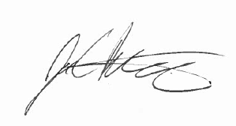Congratulations,

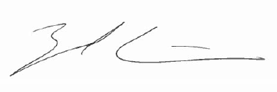

Firefighter Zach Cain [zcain@frfr.co](mailto:zcain@frfr.co)

Captain Joe Butler [jbutler@frfr.co](mailto:jbutler@frfr.co)

Station 1 Station 2

100 Telep Avenue 101 S. Irene Ave.

Johnstown, CO 80534 Milliken, CO 80543

Fax: 970.587.0324 Phone: 970.587.4464